

**NET320-Database Systems**

**SWS213-Database Design**

**Spring ‘17**

**Lab 3a**

**Lab 3a- Creating Table and Query**

**Objective**

Upon successful completion of this lab the student will be able to:

* Create schemas and tables.
* Use of basic SQL commands- SELECT

**Grading Scheme**

* This class assignment is due on 13 February 2018 at 6:00 PM.
* Students should save the Workbench file and upload to moodle.
* Save the file with your Name followed by ID.
  + Task 1 - 10 pts
  + Task 2 - 2 pts
  + Task 3 - 8 pts

**Back ground**

* Students should be familiar with the Workbench.
* Before starting the lab, make sure MySQL is running.
* Students can refer to the previous lab material (Lab 2a - Workbench Administration) for reference.

**Task 1**

1. Create a new model
2. Name Schema as ‘***Students***’
3. Create a table called ‘***Students_details***’

Add 4 Columns for

Student_ID

Student_Name

Student_Semester

Student_Section

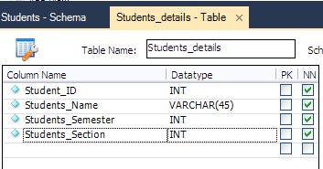

1. Save the model as ‘*StudentNameID’*
2. Create a new live database server. Enter ‘***Student Server***’ for the connection name.

**Task 2**

1. Enter the input as

|  |  |  |  |
| --- | --- | --- | --- |
| **Student_ID** | **Student_Name** | **Student_Semester** | **Student_Section** |
| 1001 | Student 1 | 2 | 1 |
| 1005 | Student 2 | 6 | 2 |
| 1009 | Student 3 | 3 | 1 |
| 1010 | Student 4 | 2 | 1 |

The output should look like

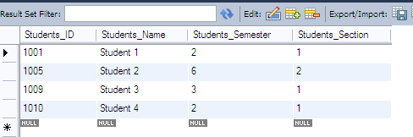

**Task 3**

Use a query to display all that you entered in schema ‘Students’.

SELECT * FROM Students.Students_details;

[SELECT SYNTAX FROM SCHEMA.TABLE NAME]

Try various SELECT queries and note down the results.

1. SELECT Students_ID FROM students.students_details;

*Results obtained*

1. SELECT Students_Name FROM students.students_details;

*Results obtained*

1. SELECT Students_Semester FROM students.students_details;

*Results obtained*

1. SELECT Students_Section FROM students.students_details;

*Results obtained*